1 1. - Average age of Stress Level by Occupation:

SELECT AVG(age) AS average_age, occupation,stress_level

FROM mentalhealth.mental_health_dataset

GROUP BY occupation,Stress_Level

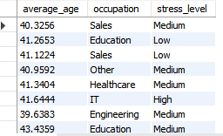

-- 2. How many people have reported having a mental health condition, broken down by country?

select count(*) as NumberofPeople,country

from mentalhealth.mental_health_dataset

where Mental_Health_Condition ='yes'

group by country

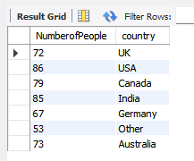

-- 3. What is the average number of sleep hours per day for each gender?

select truncate(avg(sleep_hours),2) as avgsleephours,gender

from mentalhealth.mental_health_dataset

group by gender

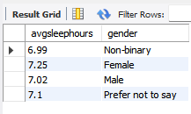

-- 4. What are the total work hours for different age groups (e.g., 30-40, 41-50, etc.)?

SELECT

SUM(Work_Hours) AS totalworkhours,

CASE

WHEN age BETWEEN 30 AND 40 THEN '30-40'

WHEN age BETWEEN 41 AND 50 THEN '41-50'

WHEN age BETWEEN 51 AND 60 THEN '51-60'

ELSE '60+'

END AS age_range

FROM mentalhealth.mental_health_dataset

GROUP BY age_range;

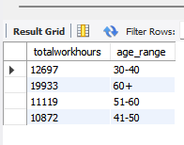

-- 5. Is there any relationship between physical activity hours and the amount of sleep per person?

SELECT Physical_Activity_Hours,

TRUNCATE(AVG(Sleep_Hours), 2) AS Average_Sleep_Hours

FROM mentalhealth.mental_health_dataset

GROUP BY Physical_Activity_Hours;

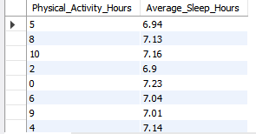

-- 6. What percentage of people with mental health conditions have a high severity level?

SELECT

(COUNT(*) / (SELECT COUNT(*) FROM mentalhealth.mental_health_dataset WHERE Mental_Health_Condition = 'yes')) * 100 AS Percentage_High_Severity

FROM mentalhealth.mental_health_dataset

WHERE Severity = 'High' AND Mental_Health_Condition = 'yes';

SELECT

(COUNT(CASE WHEN Severity = 'High' THEN 1 END) / COUNT(*)) * 100 AS High_Severity_Percentage

FROM mentalhealth.mental_health_dataset

WHERE Mental_Health_Condition = 'Yes';



-- 7.What is the average stress level of people who have consulted a healthcare professional versus those who have not?

SELECT Consultation_History, AVG(Stress_Level) AS Average_Stress_Level

FROM mentalhealth.mental_health_dataset

GROUP BY Consultation_History;

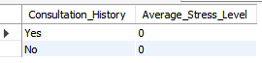

-- 8. How do work hours vary between people with and without mental health conditions?

select avg(work_hours) as averageworkhours,Mental_Health_Condition

FROM mentalhealth.mental_health_dataset

GROUP BY Mental_Health_Condition;

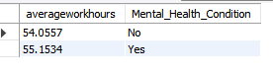

-- 9. What is the relationship between occupation and physical activity hours? Which occupation has the highest physical activity hours on average?

SELECT Occupation, AVG(Physical_Activity_Hours) AS Average_Physical_Activity_Hours

FROM mentalhealth.mental_health_dataset

GROUP BY Occupation

ORDER BY Average_Physical_Activity_Hours DESC;

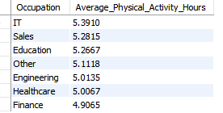

10. Which countries have the highest number of people reporting mental health conditions?

SELECT Country, COUNT(*) AS Mental_Health_Condition_Count

FROM mentalhealth.mental_health_dataset

WHERE Mental_Health_Condition = 'Yes'

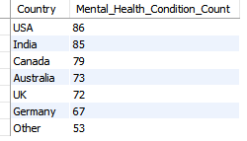

-- 11. What is the average sleep hours of people with varying work hours?

SELECT Work_Hours, AVG(Sleep_Hours) AS Average_Sleep_Hours

FROM mentalhealth.mental_health_dataset

GROUP BY Work_Hours

ORDER BY Work_Hours;

